ASSIGNMENT – 3: C PROGRAMMING

COURSE CODE: CSA0267

1.C Program to Display Prime Numbers Between Intervals Using Function

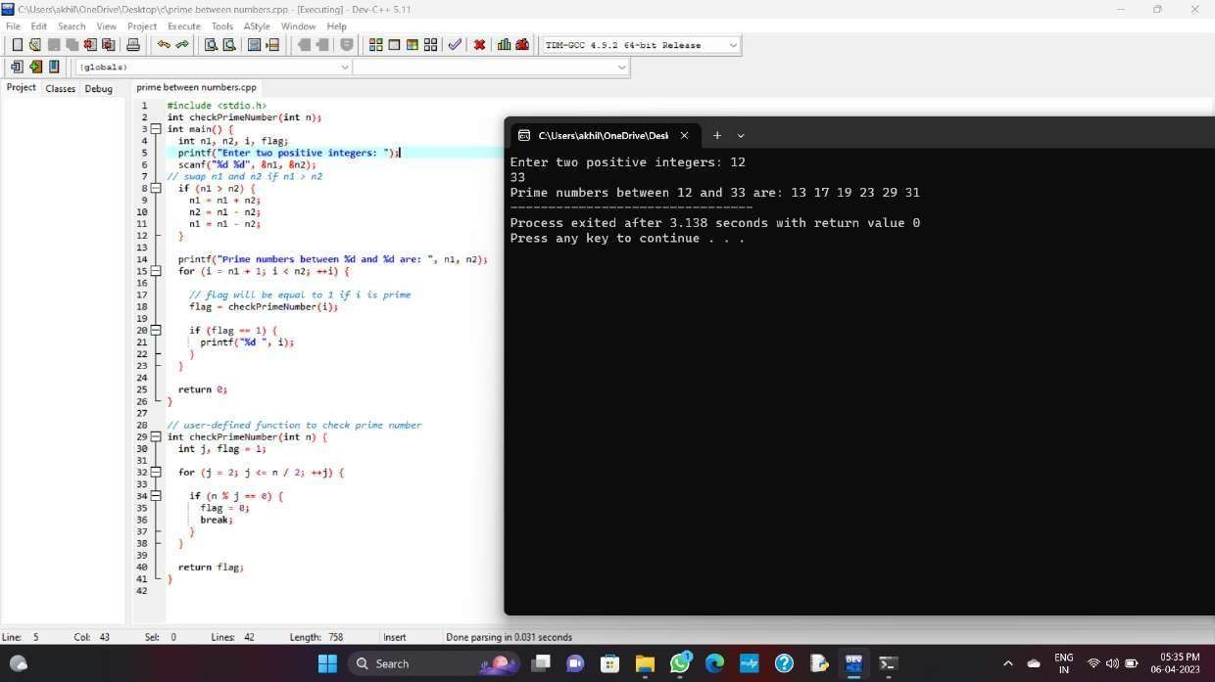

2.C Program to Check Whether a Number can be Expressed as Sum of Two Prime Numbers

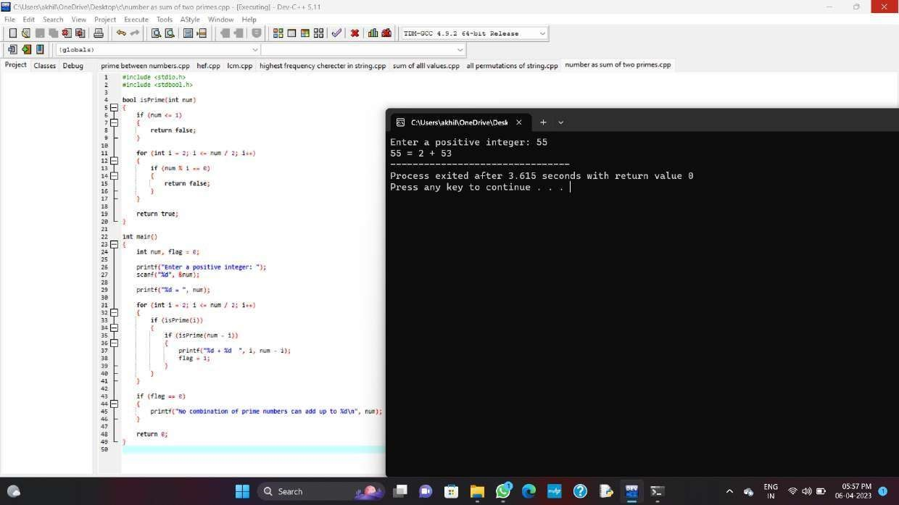

3.C Program to Find GCD of Two Numbers using Recursion

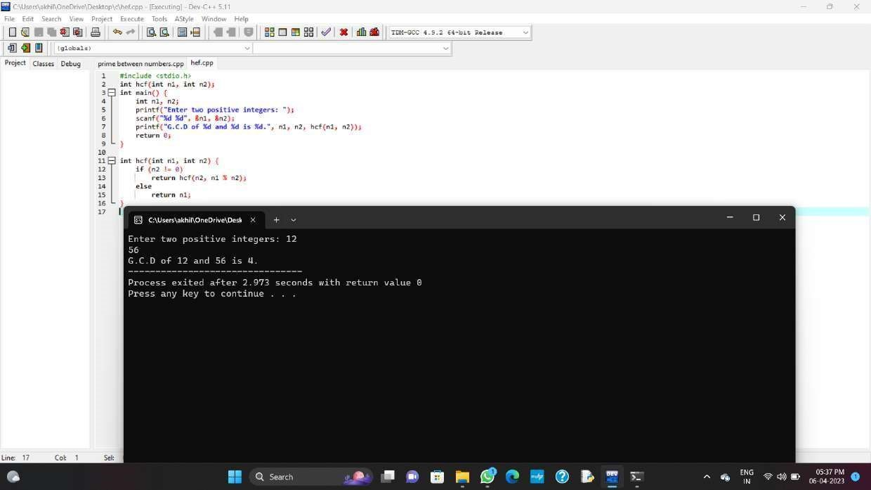

4. C Program to Find LCM of Two Numbers

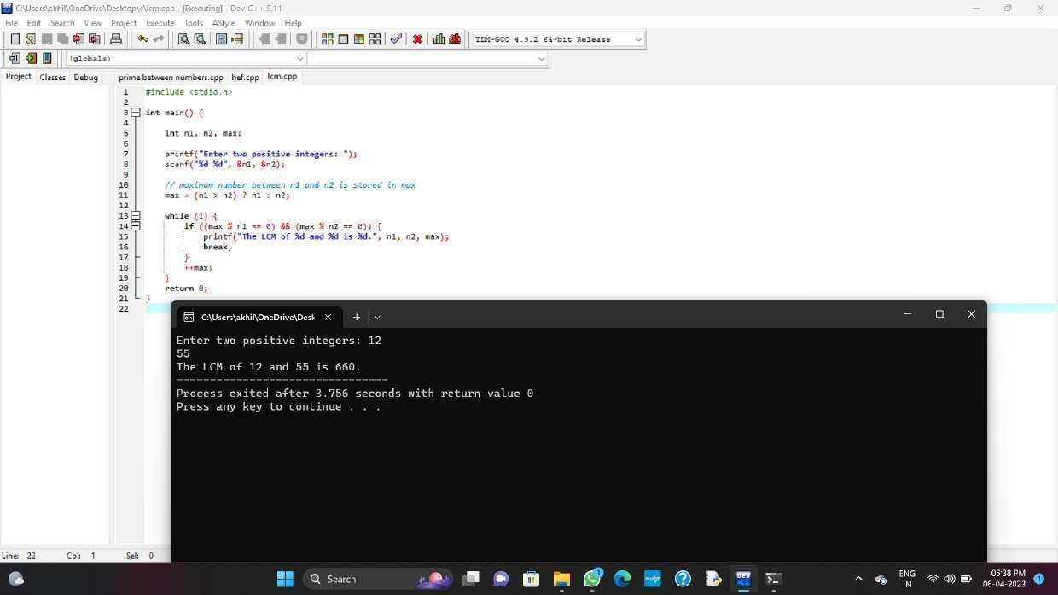

5.C Program to Find Highest Frequency Character in a String

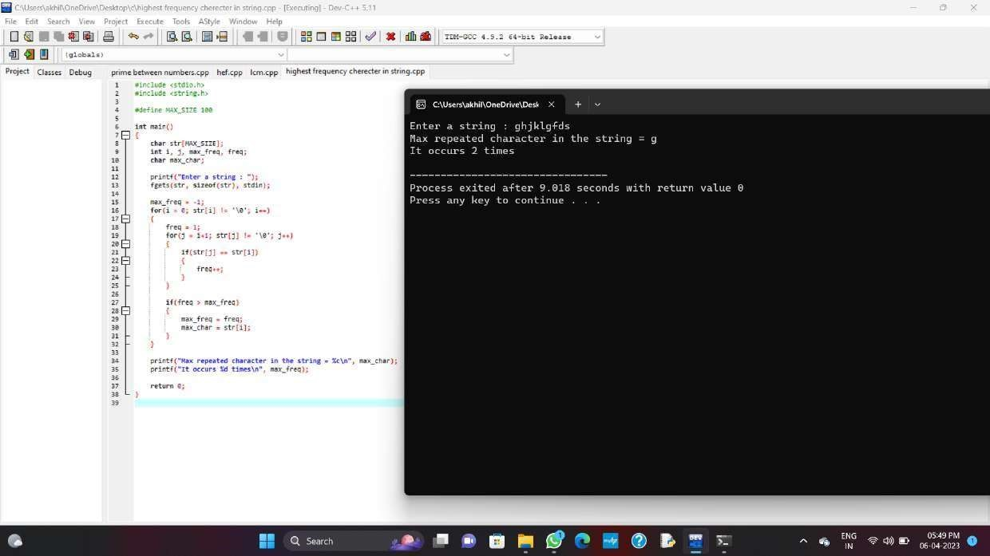

1. Anagram Program in C: Two strings are said to be anagrams if they satisfy two conditions, the length of both strings must be equal to each other and second the strings must have the same set of characters.

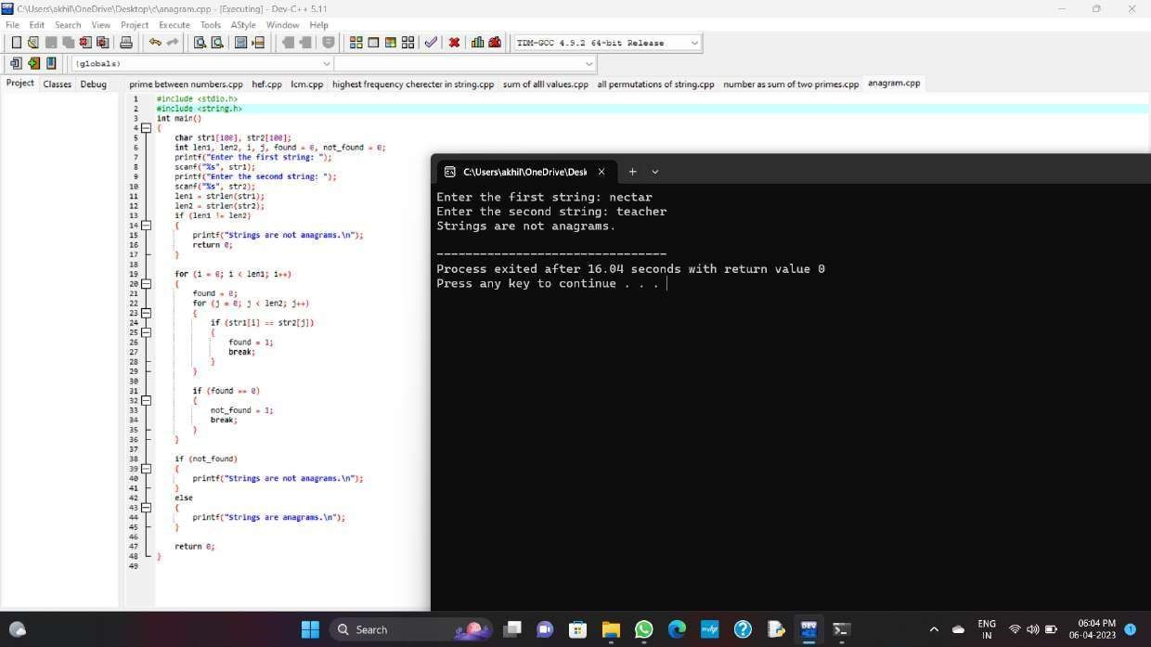

1. C Program to Find the Sum of ASCII Value of All Characters in the String

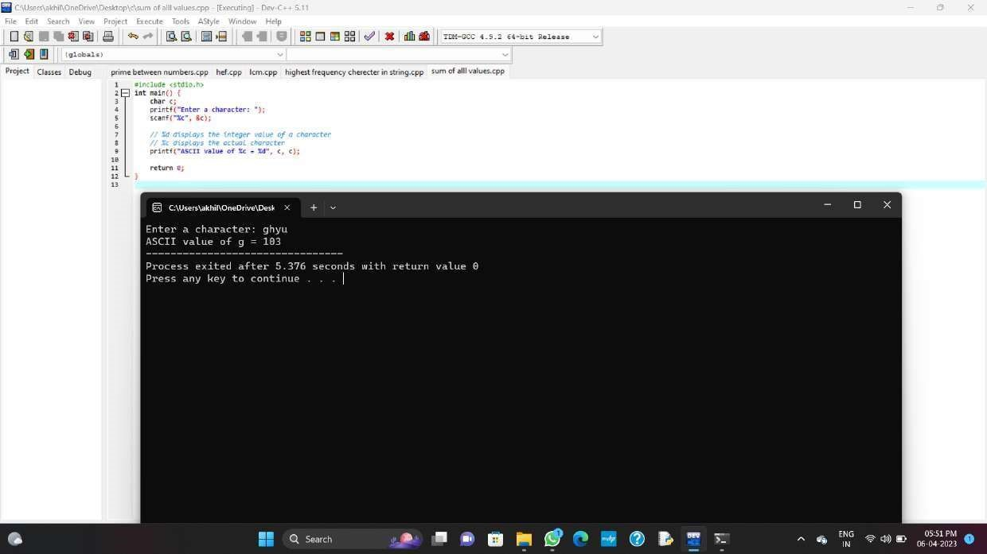

8.C Program to Print All Permutations of a Given String

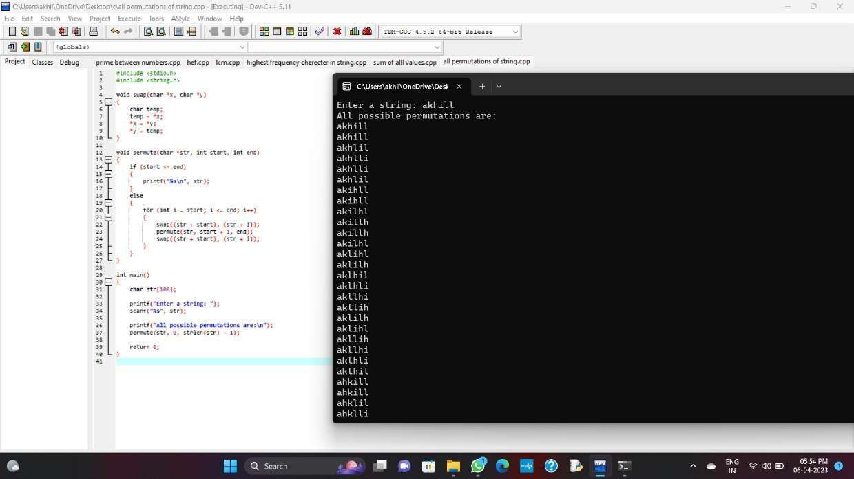

9.Write a C program to copy one array elements to another array using pointers. How to copy array elements from one array to another array using pointers. Logic to copy one array to another array using pointers in C programming.

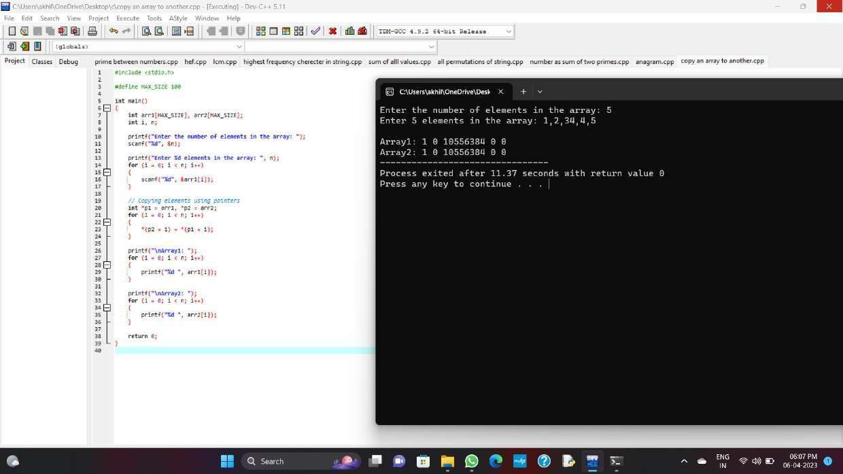

10.Write a C Program to reverse string using pointers and function.

